***Dr. Kate Lund***

***Help Your Child Bounce Back from Cyberbullying and Other Childhood Setbacks***

As a mother, psychologist and performance coach, Dr. Lund is committed to helping children build resilience in the face of challenge. Whether it be bullying, medical illness, or disability, Dr. Lund is committed in her work to helping children overcome their setbacks and move forward.

When she was a child, Dr. Lund faced significant medical challenges of her own. Sometimes, this involved surgeries that required her head to be shaved. Her difference in appearance during these episodes often resulted in taunts from her peers and other social challenges. With the support of family and friends who helped her to see beyond her challenges, she persevered.

Her book, *Bounce: Help Your Child Build Resilience and Thrive in School, Sports and Life* gives parents the tools they need to protect their children by helping them find their confidence in a time where bullying has taken on a new and more vicious form.

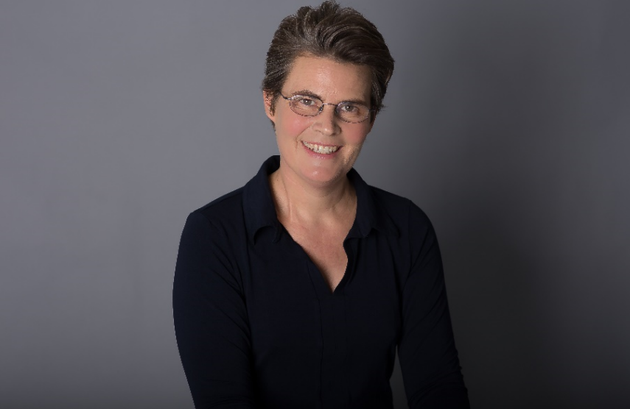

**SPEAKING TOPICS: Kate is FIRED UP to teach your audience about the benefits of building up their children’s resilience.**

**Tolerating Frustration and Managing Emotions***Has your child ever thrown their hands up in the air in frustration? Children are often just learning how to deal with the emotions they are feeling. Getting a grasp on emotional management early on can help your child deal with ANYTHING life throws at them.*

**Navigating Friendships and Social Pressure**

*It’s inevitable – your child is going to experience difficult social relationships – bullies, toxic influences, or even demanding authority figures. It’s important to teach your child to stand up for THEMSELVES while having compassion for others. By accepting individual differences and resisting peer pressure, your child will develop strong relationships with their peers and be better equipped to manage difficult interactions with bullies.*

**Developing Courage**

*For your child, new experiences can be exciting but sometimes terrifying – the first time they stand on the stage, the first time at bat, or even their first day at a new school. New environments can be overwhelming, but teaching your child how to develop COURAGE and to FACE THEIR FEARS will help them tackle these challenges. When you foster courage by encouraging your children to take risks, you unlock their potential for success.*

**ABOUT KATE**

Kate Lund is a licensed clinical psychologist with specialized training and experience in medical psychology from Shriners Burn Hospital, Boston, Massachusetts General Hospital and Beth Israel Deaconess Medical Center, all of which are affiliated with Harvard Medical School. She has vast clinical experience with children, adolescents and adults coping with medical conditions, physical disabilities and numerous other situations. Kate works with her clients to find ways to circumvent and manage challenges in order to maximize potential within their own unique context.

A picture containing text, sky

Description generated with high confidence

**ABOUT KATE :**

Kate Lund is a licensed clinical psychologist with specialized training and experience in medical psychology from hospitals associated with Harvard Medical School. She has vast clinical experience with children, adolescents and adults coping with medical conditions, physical disabilities and numerous other situations. Dr. Lund works with her clients to find ways to circumvent and manage challenges to maximize potential within their own unique context.

*For more detailed information on Kate and to book to interview please contact us:*

*Phone: 626-765-9750*

*Email:* [evamarie@BestSellerPublishing.org](mailto:evamarie@BestSellerPublishing.org)

*On the web:*

[Website](http://www.pugetsoundsportspsychology.com/books/) *|* [Linkedin](https://www.linkedin.com/in/kate-lund/)